NAME : Rhema Daphne E G COURSE : Mobile Computing
Reg No : 192321097 COURSE CODE: ITA0301

25. Create a wireframe for an Android app that utilizes background services. Use Figma to illustrate the service interactions and data flow.

Aim:
Create a wireframe for an Android app that utilizes background services using Figma

Procedure:
- Open Figma
- Create a new file
- Select the Frames
- Design Visual Elements
- Make it Interactive
- Add icons on the Frame
- Incorporate Multimedia
- Storyboard Animation
- Review and edit the Prototype
- Save and Share

Design
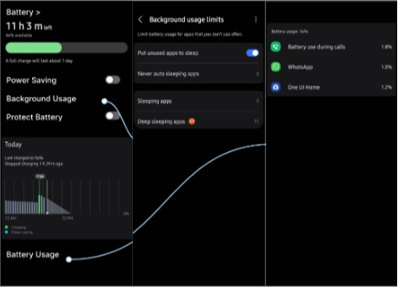

Prototype:
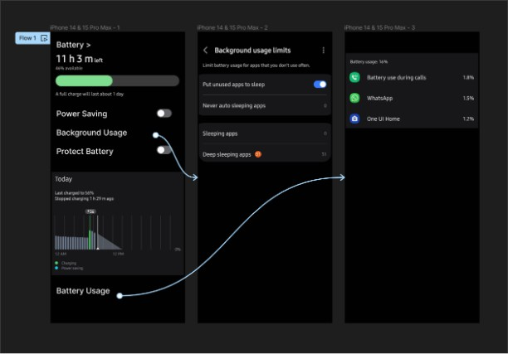

Result:
Hence a wireframe for an Android app that utilizes background services. Using Figma have been created successfully

